Media reviews on Kleifarvatn
by Arnaldur Indridason

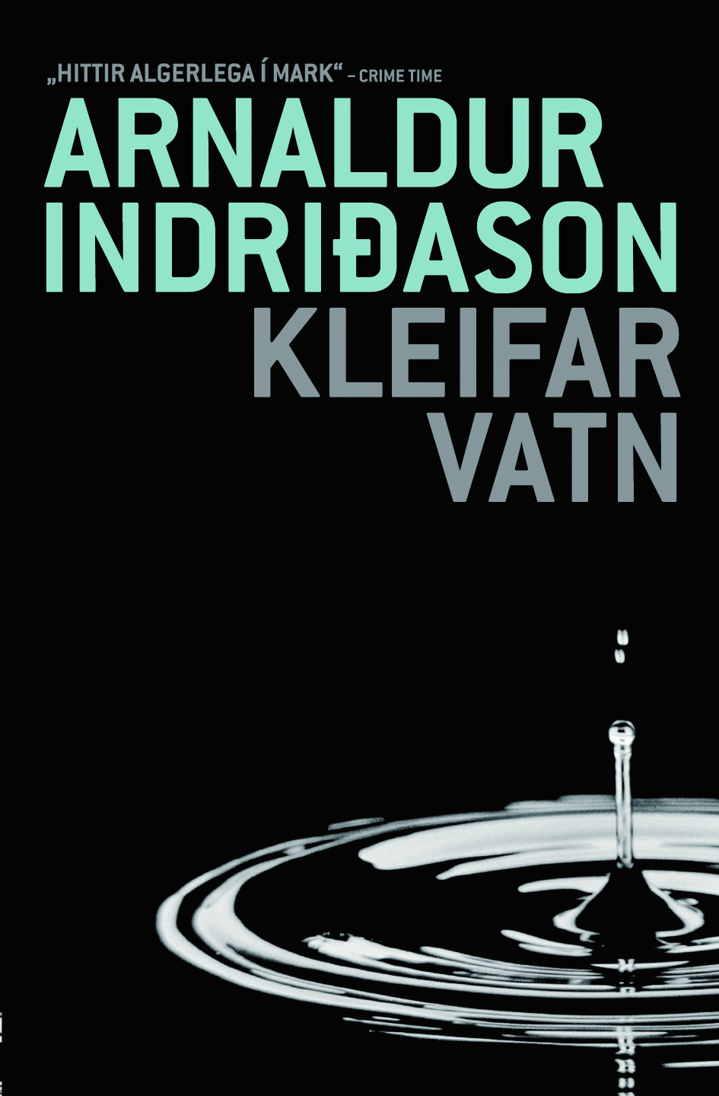

... this is clearly an author at his peak... entertaining story, exciting plot, admirable style and life-like characters. ...For a while it was a cliché with reviewers to proclaim each time a new book by him came out: “Indridason’s best book to date!” But Kleifarvatn IS Indridason’s best book to date – some of Indridason’s auxiliary stories are the best he’s ever written. For example, there is an absolutely exquisite paragraph about a man who continually phones Sigurdur Oli. And it is a sign of Indridason’s cleverness as a novel writer that such a story is never in fact completed, as could be tempting with a lesser writer.
It has been said that thrillers are some sort of substitute for popular education in modern-day society. Indridason fulfils these requirements with an admirable background around the atmosphere of the Cold War, left-wing Icelandic students who went to study in the “heavenly state” of communist East Germany, and the moral intimidation and personal espionage that was so ubiquitous then. I think that many readers will become much more knowledgeable about a time that seems so recent but undoubtedly has started to be forgotten by surprisingly many. This is a first-rate book that a person reads with interest and for good entertainment.

DV newspaper, Illugi Jokulsson

At the beginning of the story a skeleton, with a Russian transmitter attached to it, is found in the dried-up water bottom of Lake Kleifarvatn. It is obvious immediately that the skeleton is old, so everything points to the crime having been committed at the time of the Cold War. At the same time as Erlendur and his companions retrace themselves back in time after various indications, the author relates another story from the sixties that gradually approaches the present day. By the end one gets the feeling that in the final part of the story threads have been woven so that the reader sets the book down richer for the experience, and even somewhat more knowledgeable on various incidents in the political history of the fifties and sixties.
Indridason’s ability to weave together history from the past with progressive suspense from the present in a complex story, along with adding personal histories of the main characters from earlier books, has become singularly trustworthy.

Morgunbladid newspaper, Havar Sigurjonsson

Disappearance – but never disappears
Disappearances are one of the main themes in Arnaldur Indridason’s books, as they are a particular interest of research detective Erlendur, who is undeniably the main character in most of Indridason’s books. Erlendur’s interest in missing people has its roots in painful childhood memories: his younger brother disappeared from a heath in the eastern fjords of Iceland in bad weather, while he himself, along with his father, made a narrow escape. This tragic event lives on within Erlendur; it is part of his personality and explains various things about his nature. And other “disappearances” make their mark on his life, as with his divorce he himself disappeared from the lives of his two children, Eva Linda and Sindri, when they were very young. When they later – and separately – look him up, the distance between them and their father seems unbridgeable, as it is laden with unresolved guilt, rejection and remorse, sorrow and bad feeling.
This strand, the private life of Erlendur Sveinsson, is one of the side threads in Indridason’s books, as readers know, but it is an important thread as it links the books with each other – and readers with Erlendur. In each book, readers learn more about Erlendur’s background, and the image of him deepens. The same applies to his colleagues, Sigurdur Oli and Elinborg: bit by bit, descriptions of these two are added, and as with Erlendur, they become closer to the reader.
But despite the undeniable interest of readers in the police trio and their private lives, it is of course always some crime that is the focus and in fact the main storyline of each book. Undoubtedly it is like carrying coals to Newcastle to repeat what everyone knows – that Indridason has grown and strengthened with every book. His main strengths appear to be three: firstly, there have been enormous advances in Indridason’s style from his first work to his latest. Secondly, he has not stagnated in a predetermined formula; rather, it appears that he has attempted to investigate dissimilar forms within the thriller tradition, and he is increasingly adept at weaving together many story threads, telling many stories in parallel. Thirdly, Indridason has managed extremely well to locate his stories in Icelandic reality as we know it. This last point undoubtedly is the most important, and scepticism that this could even be possible is surely the reason why crime fiction has been so slow to take hold in Icelandic literature.
In Kleifarvatn, like in his earlier works, missing people are the focus, but the framework is more in line with detective stories. The story is composed of two main themes. One is the story of the finding of a skeleton in Lake Kleifarvatn and the police attempts to discover who the person concerned was. The other is the story of a young Icelandic student in East Germany in the late sixties. In both of these, people disappear and in both the lovers of the missing people wallow in grief that takes time to heal. These are stories of people who disappear – but who never disappear completely, as their fate is not clear. And the anxiety of those who live on is something Erlendur understands well.
No more will be said about the plot here, except to say that it is admirable how well Indridason utilizes the Cold War discussion of the last decades and how his text points in various directions: to hot topics of society, to recent natural disasters, to history, to literature. He tells a tale of hopes and disappointments, of broken dreams and betrayals, and weaves all the story threads professionally together. Without any doubt, Kleifarvatn is Indridason’s best book, the story material thoroughly rooted in Icelandic reality and – in this case – also in the international reality of broken visions of socialists, misuse of power, murder, and oppression in Eastern Europe at the time of the Cold War. This book should not disappoint Arnaldur Indridason’s readers, and has every opportunity to succeed abroad no less than here in Iceland.
Morgunbladid newspaper, Soffia Audur Birgisdottir

Interview with the author
It was not particularly surprising when Kleifarvatn, Arnaldur Indridason’s new crime novel, shot to the top of the Icelandic best-seller list only a few days after publication. Kleifarvatn is not inferior to the best books of the best-selling author, Myrin and Grafarthogn. In this new book, Icelandic students in East Germany play a part in the story.
“I have been to Leipzig three times to promote my books. In my travels around the city I wandered into the Stasi Museum. It was there that I got the idea of writing a novel about the Cold War that could conceivably take place in Leipzig. Iceland is linked to this city historically and culturally, as Icelanders were studying there during the Cold War,” says Indridason. “Around that time I read in a newspaper that the water level of Lake Kleifarvatn had fallen, and I remembered that spy equipment had been found there in 1973. That sparked off the idea for the beginning of the story, which in my mind gradually became a Cold War novel with spies, love, betrayal and the whole caboodle. I also work with missing people in the book, like I’ve done in my earlier books, as missing people have been an interest of mine for a long time, and are certainly Erlendur’s main interest.”
…
Perhaps more so than in Indridason’s other books, Kleifarvatn reflects how much detail the author has paid to small details that are not directly connected to the storyline but nevertheless deepen the novel; minor characters have also acquired more importance. “When I sit down to write, I don’t know exactly what will happen. When I began this book I had the themes of missing people and the Cold War. When the actual work began, all the other little ideas came. Day after day I sit at the computer, try to think of something and write; I stick at it and try to discipline myself. I have always tried to have so-called ‘side themes’ to expand the novel, and side characters to enlarge the people gallery”, says Indridason. “At the same time I take care to keep a clear picture of the material itself, which in this book revolves on the tremendous shock that occurs in the life of a person who discovers that a loved one has disappeared. How does the person react? What does s/he do? Does s/he blame her/himself? Is s/he guilty? Is it possible to recover from the shock at some point? Luckily I don’t know the answers from my own experience, but I try to set myself in the footsteps of those who are subject to this and try to imagine the horror that such a person has to endure and then how s/he continues with life.”
…
Does Indridason find that, as an author, he has to take on society ills in his works?
“Yes, in some way I end up doing that. If a person is an author, the person must think s/he has a message of some sort. I find I have something to put across and I have shown that I am taking on the challenge of the society I live in. I do it consciously and keep track of what’s happening in society. However, I don’t want to only cover what is reported in the media; I also want to focus on what happens outside of the limelight. For instance, I write a lot about the family. Families that are kaput. Families that should exist but don’t. And then I write about the environment, houses, streets, the weather, Reykjavik and Iceland. I try to reflect Icelandic reality in my books. Otherwise I feel they have little value.”
Frettabladid newspaper, F2, Kolbrun Bergthorsdottir

Lake Kleifarvatn has waited for centuries for Arrnaldur Indridason. This mysterious lake that comes and goes in its uncanny bleakness deserves no less than Indridason’s talents to create the suitable atmosphere of fear and heartache. Just as with the Nordurmyrin district (where Myrin was set), which will never be the same in the mind of this reader, Lake Kleifarvatn has become part of literature.
Erlendur, Elinborg and Sigurdur Óli meet again in good form. Indridason continues to fill out the characters and develop their history, and they even seem to have developed somewhat and learnt something from prior experience. This is not to say that they no longer have their faults and eccentricities, which the author utilizes not only to show that they are human and weak, but also as an ascendant in the chain of events. Each and every person, even those who come into the story only marginally, gets a firm touch, which must be considered one of the main talents of the author – no person is too unremarkable or insignificant to be exempt from character descriptions. The style is effortless, the conversations gripping – often amusing – and it is good to hear again about Marion who, as before, never fails.
Indridason tries yet another type of crime story in this book, and proves yet again that Icelandic crime fiction is not impossible if approached in the right way. There is no attempt to make a foreign country out of Iceland; it is much more likely that the format has come in its true colours, without missing out on the mysterious suspense that characterizes it. At times the plot is perhaps foreseeable, but that doesn’t matter: sometimes it’s actually a strength to point to how a chain of events can become unavoidable and power can be taken away from people.
Erlendur’s particular interest, old instances of missing people, enters the story yet again; people appear and disappear (just like the lake) and the fog of time lightens for a while, so the forgotten past comes suddenly to light. Time stops, uncertainty becomes an ongoing state, the reality only one possibility of many. The disappeared have a particular and haunting presence that it is not possible to wave aside – they are living and dead at the same time (and remind one of Schrödinger’s cat). And sometimes it is even as if they never existed. These threads are woven together in the work in an unpretentious way, both in character creation and chain of events, to produce a sombre but sincere crime story that is nonetheless a contemplation of a review of the past, love, loss and nostalgia. It is all too easy to say too much in reviews on crime fiction, so in order not to spill the beans for the reader, not another word will be said.
www.bokmenntir.is the website of Reykjavik City Library, Gunnthorunn Gudmundsdottir, November 2004

… recommend it without hesitation… If this book was to be published in Germany, of which there is no doubt, it will draw the attention of more people than previously to the relations between Icelanders and East Germans, which were unique and often caused heated discussions in Iceland, not least when the so-called SIA report appeared about 40 years ago. In that, contemporary descriptions can be found of Icelandic students in East Germany and their views on social issues and student life.
… He throws a factual light on the tension that set the tone on human relations in the time of the Cold War, and which encouraged the governments of other states to maintain operations here but which in no way stooped to cultivating bilateral relations with the Icelandic government.
Arnaldur Indridason’s books hit the target, because they are written with the knowledge to tell a story in an exciting and entertaining way, without relaxing the requirements of good treatment.
www.bjorn.is the website of Bjorn Bjarnason, ex-Icelandic Department of Education Minister

